Niger

## Political Stability Estimate Data

The data set shows the political stability estimate of the country each year.

## # A tibble: 19 x 5  
## country iso3c date stability stabilityCategory4   
## <chr> <chr> <dbl> <dbl> <chr>   
## 1 Niger NER 1996 0.0263 moderately stable   
## 2 Niger NER 1998 -0.314 moderately unstable  
## 3 Niger NER 2000 0.125 moderately stable   
## 4 Niger NER 2002 -0.128 moderately unstable  
## 5 Niger NER 2003 0.0427 moderately stable   
## 6 Niger NER 2004 -0.506 moderately unstable  
## 7 Niger NER 2005 -0.488 moderately unstable  
## 8 Niger NER 2006 -0.227 moderately unstable  
## 9 Niger NER 2007 -0.458 moderately unstable  
## 10 Niger NER 2008 -0.668 moderately unstable  
## 11 Niger NER 2009 -1.15 highly unstable   
## 12 Niger NER 2010 -1.16 highly unstable   
## 13 Niger NER 2011 -0.878 moderately unstable  
## 14 Niger NER 2012 -1.15 highly unstable   
## 15 Niger NER 2013 -1.32 highly unstable   
## 16 Niger NER 2014 -1.18 highly unstable   
## 17 Niger NER 2015 -1.07 highly unstable   
## 18 Niger NER 2016 -1.10 highly unstable   
## 19 Niger NER 2017 -1.30 highly unstable

## Political Stability Estimate Plot

The plot shows the trends of stabilization and destabilization for the each country.

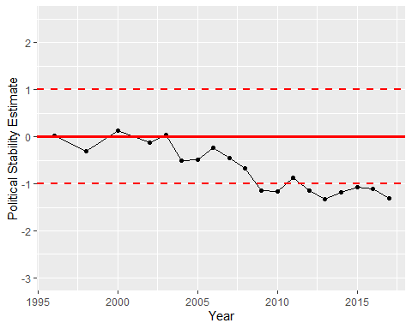

Political Stability Trend